SettingUpApplicationEnvironment

DockerInstallation

|  |  |
| --- | --- |
| Date | 10 November 2022 |
| TeamID | PNT2022TMID50435 |
| ProjectName | SmartFashionRecommender Application |
| TeamMembers: | TAMIL SELVAN ARUNVIGNESH  MATHESH  MOSAI |

# Step1:

***[install/](https://docs.docker.com/desktop/install/windows-install/)***

GotheofficialDockerwebsite:***[https://docs.docker.com/desktop/install/windows-](https://docs.docker.com/desktop/install/windows-install/)***

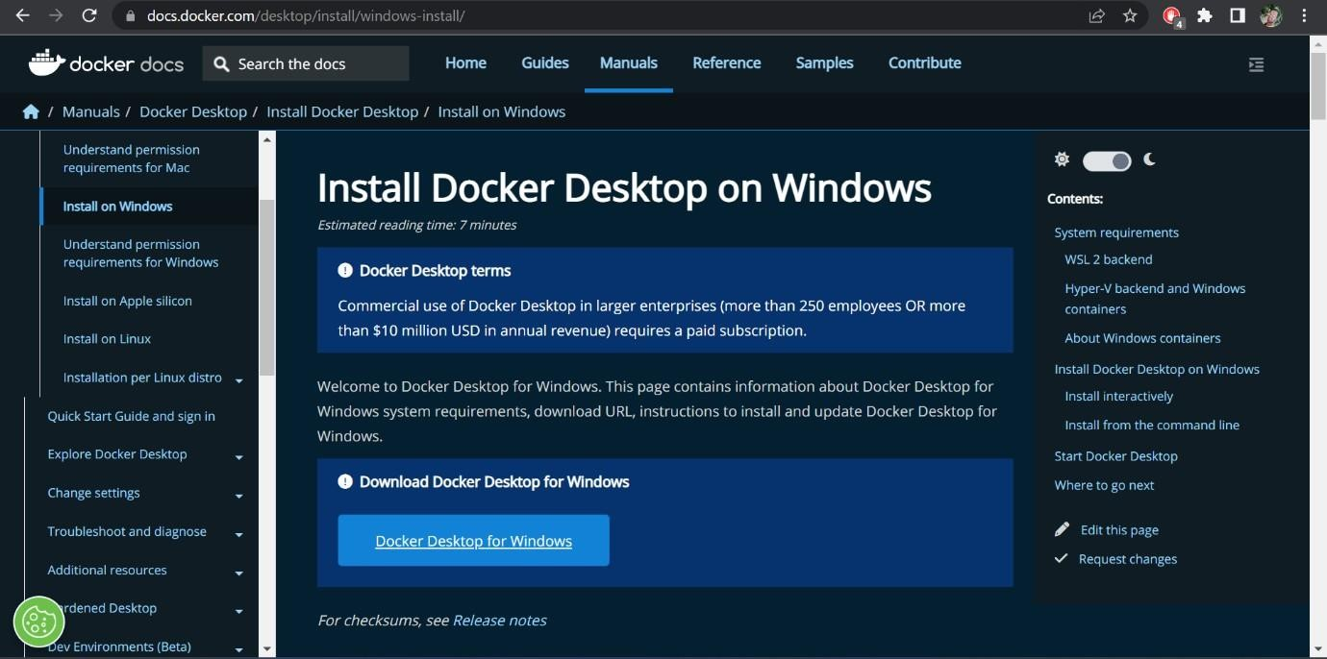

# Step2:

Clickthatbutton (Docker DesktopforWindows)anddownloadwillstartandittakes

fewminutestocomplete.

# Step3:

Gotodownloadsinbrowser(or)type**ctrl+J**,itwillnavigatetodownloadpageanddouble-clicktheparticulardockerfile.

# Step4:

NowInstallationiscomplete.Thisiconwasaddedinyourdesktop.Double-clicktheicontostartthedockerapp,youcanregisterand login thatapptoaccessthosecredentials.

# Step5:

Dockerwillstartcorrectly,theleftbottomsidewas showningreencolor,dockerwill

showthestatusofdockerapp workingsuccessfully.

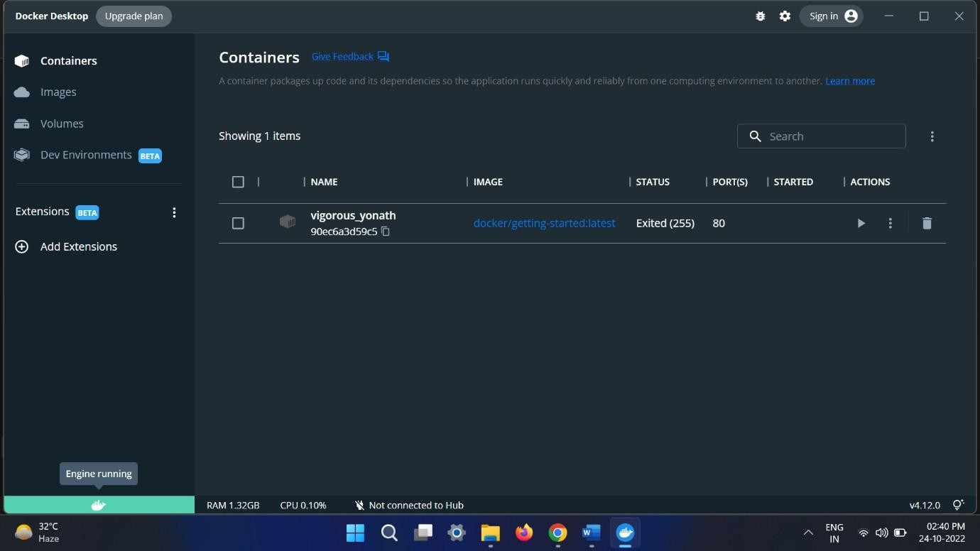

# Step6:

Finally,thedockerisinstalledsuccessfully.